Flutter Roadmap

Stage11 – Local Storage, Packages and Assets

Prepared by:
Momen Mohammed Kraizem
Computer Engineering Graduate
16 sep 2026

Profile with Assets Image
Already done – like this one on stage 07
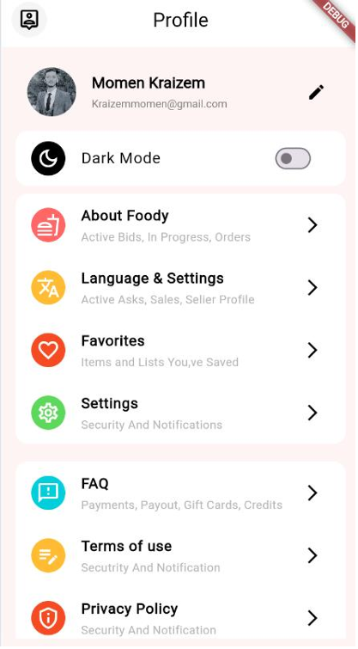

SVG
Already done in tasks
Ex:
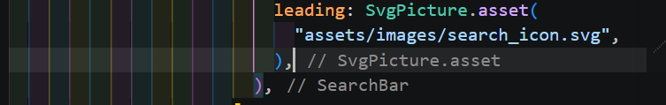

Open external link
import 'package:flutter/material.dart';
import 'package:url_launcher/url_launcher.dart';

class ExercisesStage11 extends StatelessWidget {
const ExercisesStage11({super.key});

Future<void> openWebsite() async {
final Uri url = Uri.parse('https://www.google.com');

await launchUrl(url);
}

@override
Widget build(BuildContext context) {
return Scaffold(
body: Center(
child: ElevatedButton(
onPressed: openWebsite,
child: const Text('فتح الموقع'),
),
),
);
}
}

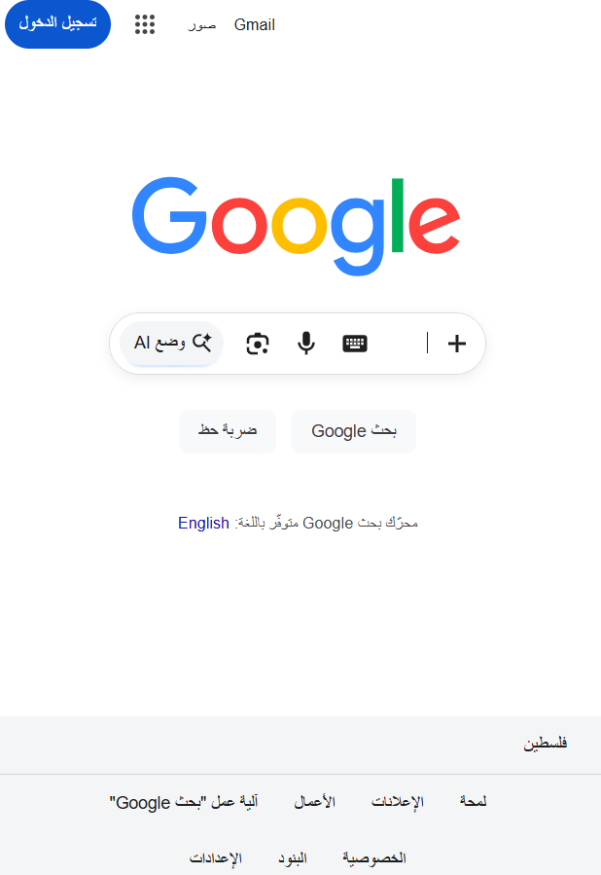 | 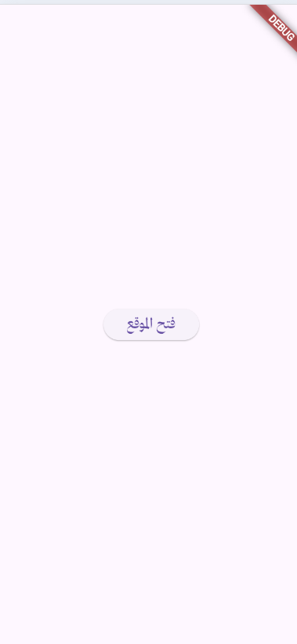

Save username
Login Screen
import 'package:flutter/material.dart';
import 'package:shared_preferences/shared_preferences.dart';
import 'package:stage10/screens/stage11/Home.dart';

class Login extends StatelessWidget {
TextEditingController controller = TextEditingController();

Login({super.key});

@override
Widget build(BuildContext context) {
return Scaffold(
body: Center(
child: SizedBox(
height: 100,
child: Column(
children: [
TextFormField(
controller: controller,
decoration: InputDecoration(hintText: "Enter youe username"),
),

MaterialButton(
onPressed: () async {
SharedPreferences pref =
await SharedPreferences.getInstance();
await pref.setString("username", controller.text);

await pref.setBool("loggedin", true);
Navigator.of(context).push(
MaterialPageRoute(
builder: (context) {
return Home(username: pref.getString("username")!);
},
),
);
},
child: Text("Login"),
),
],
),
),
),
);
}
Main
import 'package:flutter/material.dart';
import 'package:shared_preferences/shared_preferences.dart';
import 'package:stage10/managers/manager_font_family.dart';
import 'package:stage10/screens/stage11/Home.dart';
import 'package:stage10/screens/stage11/Login.dart';

void main() async {
WidgetsFlutterBinding.ensureInitialized();

SharedPreferences pref = await SharedPreferences.getInstance();

bool loggedin = pref.getBool("loggedin") ?? false;
String? username = pref.getString("username");

runApp(MyApp(loggedin: loggedin, username: username));
}

class MyApp extends StatelessWidget {
final bool loggedin;
final String? username;

const MyApp({super.key, required this.loggedin, required this.username});

@override
Widget build(BuildContext context) {
return MaterialApp(
theme: ThemeData(fontFamily: ManagerFontFamily.mainFont),
home: loggedin ? Home(username: username!) : Login(),
);
}
}

After hot restart   | Home screen   | Login screen  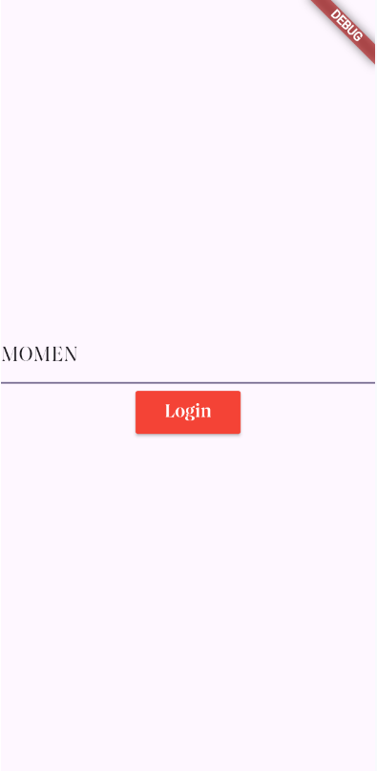

Change and save a theme
Hot restart  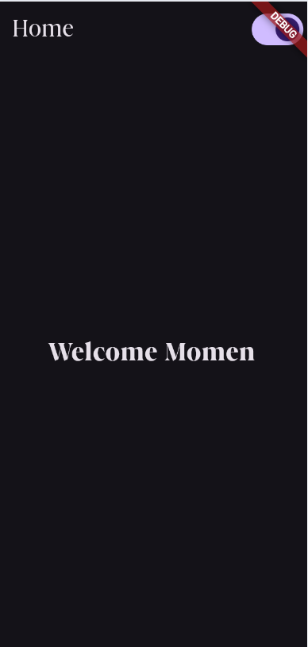 | Theme changed  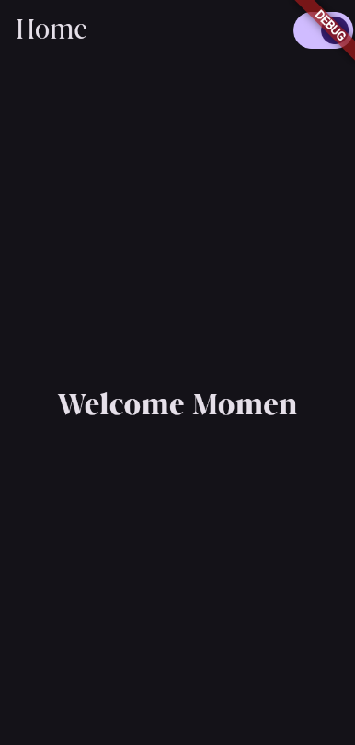 | Before chnging the theme  